STRIDE LOGISTICS
Email Campaign Manager
Complete Operations Guide
Version 2.4 — March 2026
Prepared for Justin Tong
justin@stridenw.com

Table of Contents
1. System Overview
2. Getting Started (First-Time Setup)
3. Understanding the Spreadsheet Tabs
4. Creating Your First Campaign
5. Running the Designer Prospecting Campaign
6. Managing Active Campaigns
7. Creating Email Templates
8. Working with Contacts
9. Daily Operations
10. Troubleshooting
11. Quick Reference Card

1. System Overview
The Stride Campaign Manager is an email marketing system built on Gmail, Google Apps Script, and Google Sheets. It lets you send branded HTML emails to interior designers and architects, manage follow-up sequences, track replies and conversions, and handle unsubscribes automatically.

What It Can Do
Send one-time email blasts to a targeted group (e.g., announce a new service to existing clients).
Run multi-step sequences with automatic follow-ups spaced days apart (e.g., the designer prospecting campaign with Initial + 3 follow-ups).
Run multiple campaigns simultaneously with priority and conflict rules.
Automatically detect replies, bounces, and unsubscribe requests.
Send you a daily digest email with campaign performance stats.

How It Works
Everything is controlled from one Google Sheet with 8 tabs. The Apps Script code runs in the background on a daily schedule. You manage campaigns using the Stride Campaign menu in the spreadsheet toolbar.
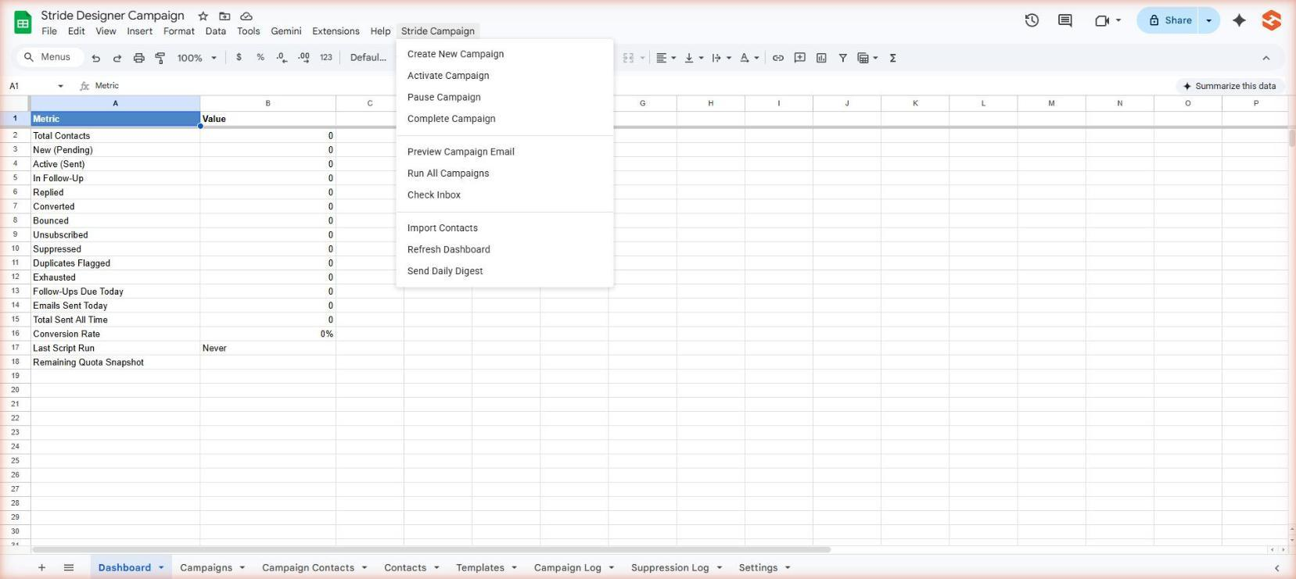
Google Sheet toolbar showing the Stride Campaign custom menu

WARNING: Never send emails without first testing in Test Mode. Always preview before activating a campaign.

2. Getting Started (First-Time Setup)
If you have already run setupCampaign() and see all 8 tabs in your spreadsheet, skip to Section 4.

Step-by-Step First-Time Setup
Step 1: Open Google Apps Script at script.google.com and create a new project (or open your existing one).
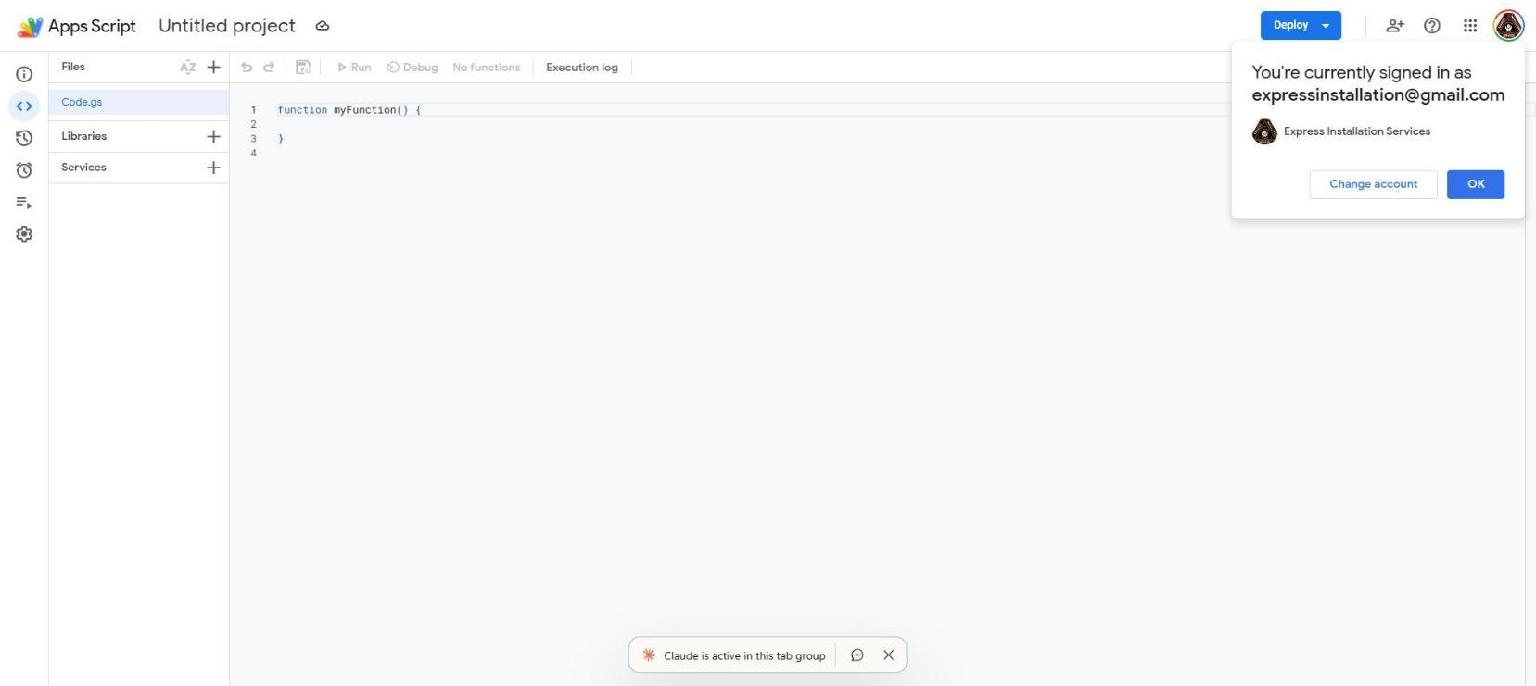
Apps Script editor with new project open
Step 2: Delete the default myFunction() code. Paste the entire stride-campaign-v2.4 code into Code.gs.
Step 3: Click the Save button (floppy disk icon) or press Ctrl+S.
Step 4: In the function dropdown at the top, select setupCampaign. Click Run.
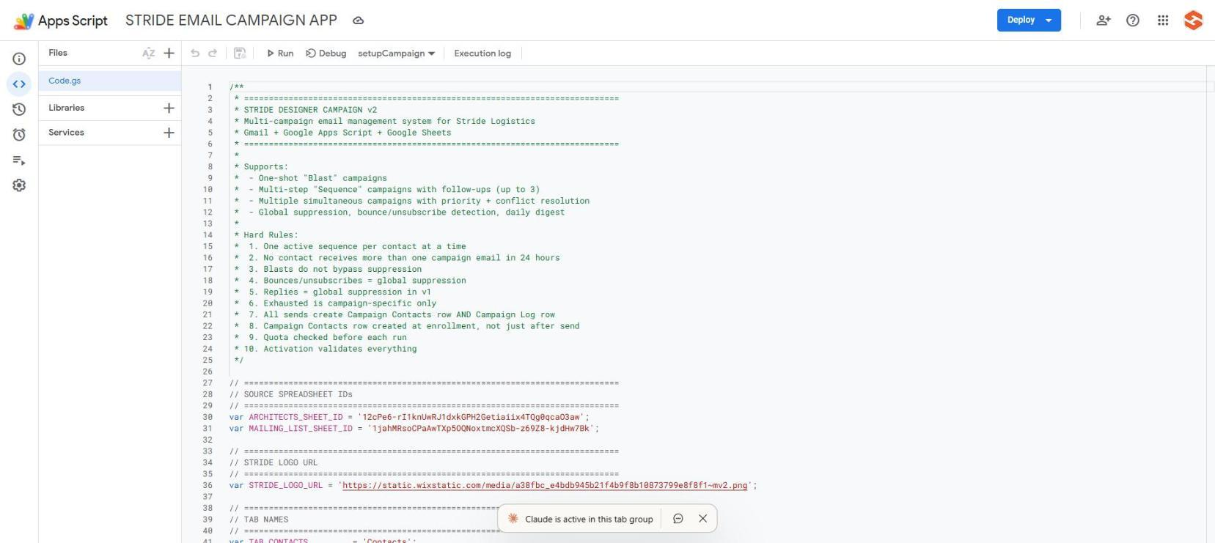
Apps Script editor showing setupCampaign selected in the function dropdown
Step 5: Google will ask you to authorize the script. Click Review Permissions, choose your account, click Advanced, then click Go to [project name] (unsafe), then Allow.
Note: The Google authorization dialog appears only on first run. Click Review Permissions, choose your account, click Advanced, then click Go to [project name] (unsafe), then Allow.
Google authorization dialog
Step 6: Wait for the script to finish. Check the Execution Log at the bottom for Setup complete and the new spreadsheet URL.
Step 7: Open the spreadsheet. You should see 8 tabs: Dashboard, Contacts, Campaigns, Campaign Contacts, Templates, Campaign Log, Suppression Log, Settings.
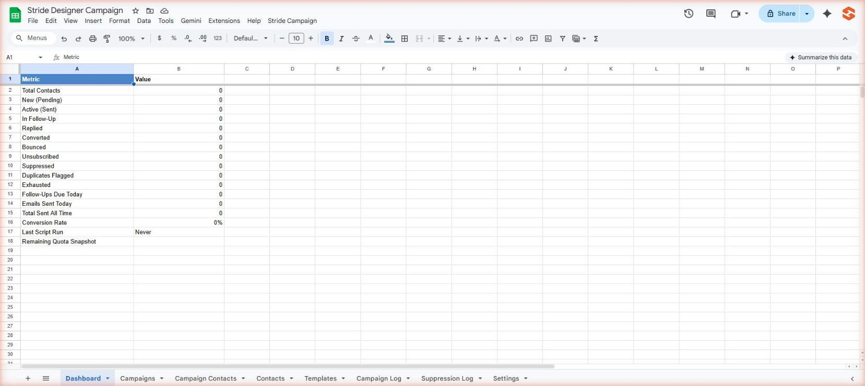
Spreadsheet with all 8 tabs visible at the bottom
Step 8: Close and reopen the spreadsheet. The Stride Campaign menu should now appear in the toolbar.

Deploy the Unsubscribe Web App
Step 1: In the Apps Script editor, click Deploy (top right) then New Deployment.
Step 2: Click the gear icon next to Type and select Web App.
Step 3: Set Execute as to Me and Who has access to Anyone.
Step 4: Click Deploy. Copy the URL that appears.
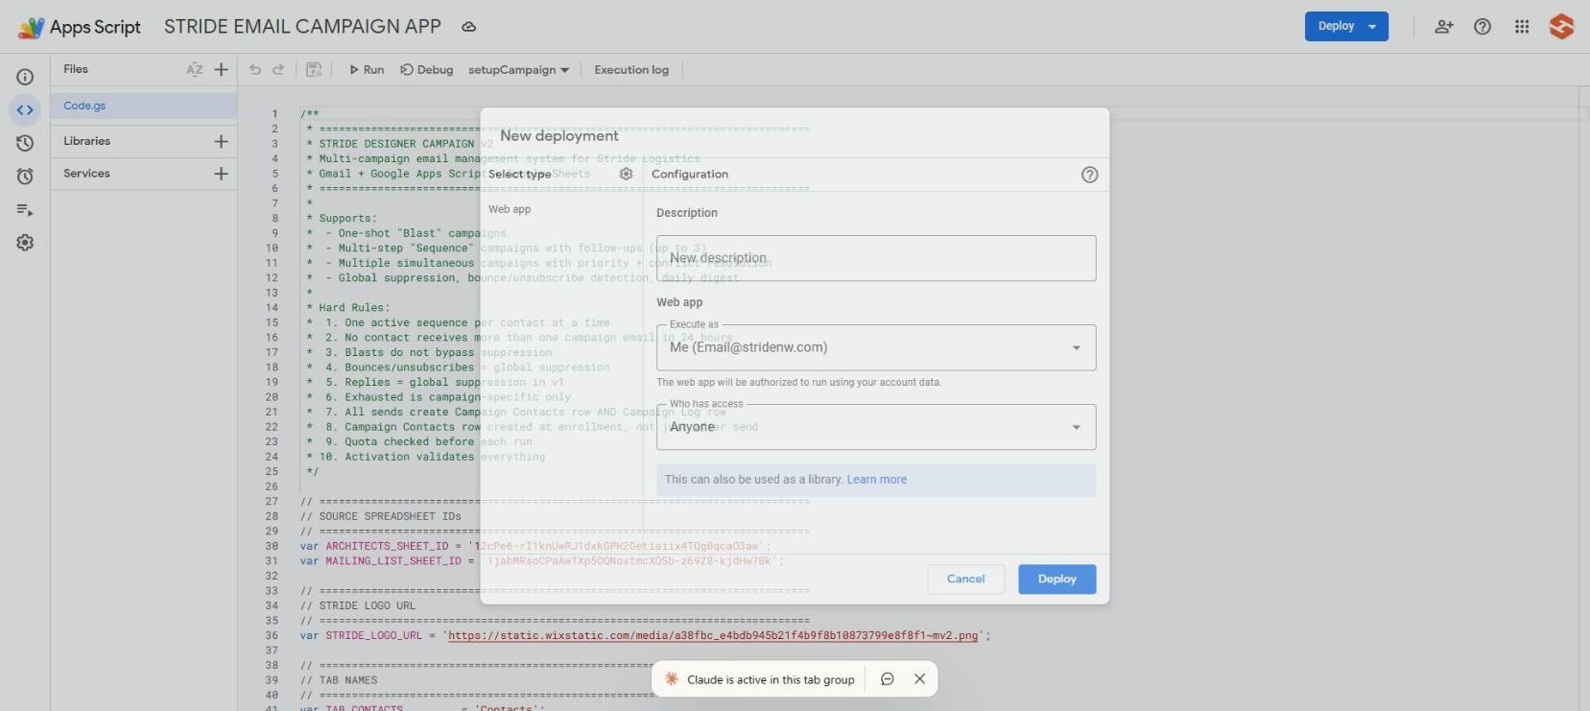
Deployment dialog showing the web app URL
Step 5: Go to the Settings tab in your spreadsheet. Find Unsubscribe Base URL and paste the URL in the Value column.

TIP: Test the unsubscribe URL by adding ?token=test123 to the end and opening it in your browser. You should see a branded Stride Logistics unsubscribe confirmation page.

3. Understanding the Spreadsheet Tabs

Contacts
Your master contact list. Every person you might email is here. Each row is one contact with their name, email, company, and status. New contacts can be added anytime. The system reads this tab to find eligible people for each campaign.

Campaigns
One row per campaign. This is where you define what to send, who to send it to, how many per day, and whether follow-ups happen. You create, activate, pause, and complete campaigns from this tab using the menu.

Campaign Contacts
The history table. One row per contact per campaign. Shows exactly what happened: when they were enrolled, what emails they received, whether they replied, bounced, or unsubscribed. Never edit this tab manually.

Templates
Where you store your HTML email templates. Each row has a template name, subject line, preview text, and the full HTML body. The script reads templates by name, so the name must match exactly what you put in the Campaigns tab.

Campaign Log
A permanent record of every send attempt. One row per email sent (or attempted). Shows success/failure, which campaign, which template, and any error messages. Never delete rows from this tab.

Settings
Global settings that apply to all campaigns: your digest email, booking URL, unsubscribe URL, sender name, phone, and website. Campaign-specific settings (like daily send limit) are in the Campaigns tab instead.

Dashboard
High-level stats. Refresh it using the menu: Stride Campaign > Refresh Dashboard.

Suppression Log
Permanent audit trail of every suppression event (bounces, unsubscribes, replies). Never delete rows.

4. Creating Your First Campaign

Before You Start
Make sure you have: (1) at least one HTML email template pasted into the Templates tab, (2) contacts imported into the Contacts tab, and (3) the unsubscribe web app deployed.

Step-by-Step
Step 1: Click Stride Campaign in the toolbar, then click Create New Campaign.
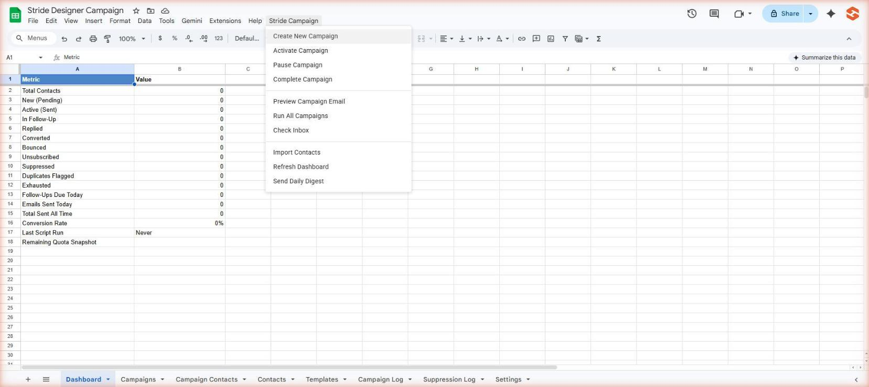
Stride Campaign menu with Create New Campaign highlighted
Step 2: A dialog will ask for a campaign name. Enter something descriptive like Designer Prospecting Q1 or Software Launch Blast. Click OK.
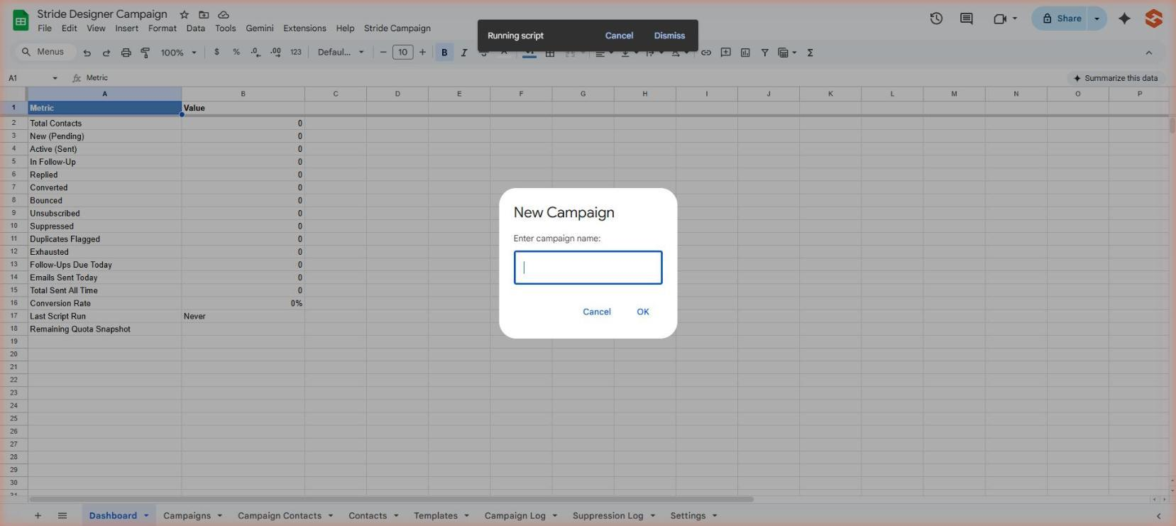
Campaign name input dialog
Step 3: A new row appears in the Campaigns tab with Status = Draft. Now fill in the fields:

Campaign Type
Sequence = initial email + automatic follow-ups (up to 3). Choose this for prospecting campaigns.
Blast = single email, no follow-ups. Choose this for one-time announcements.

Priority
Lower number = higher priority. If a contact qualifies for multiple campaigns, the highest priority campaign sends first. Default is 10. Use 1-5 for important campaigns.

Target Type
All Active Leads = contacts with Status = Pending (not yet emailed).
Existing Clients = contacts with Existing Client = TRUE.
Non-Clients = contacts with Existing Client = FALSE/blank.
Campaign Tag = contacts whose Campaign Tag column matches your Target Value.
Manual List = same as Campaign Tag, just a different label for clarity.

Enrollment Mode
Dynamic = the system checks for new matching contacts on every run. Good for ongoing campaigns where you keep adding contacts.
Snapshot = the system enrolls matching contacts once at activation. The list is frozen. Good for one-time targeted sends.

Templates
Enter the exact Template Name from the Templates tab. For a Sequence campaign, fill in Initial Template and up to 3 Follow-Up templates. For a Blast, only fill in Initial Template.

Send Settings
Daily Send Limit: Start with 20-50. After 2 weeks with no issues, increase to 100.
Send Window: Default 8 AM to 5 PM Pacific. Emails outside this window wait until the next day.
Max Follow-Ups: 0 for Blast, 1-3 for Sequence.
Follow-Up Interval Days: How many days between each email. Default 7.

Test Mode
ALWAYS set Test Mode = TRUE and enter your email in Test Recipient when first creating a campaign. This sends all emails to you instead of real contacts.
WARNING: Never set Test Mode to FALSE until you have previewed the email and confirmed everything looks correct.

Step 4: Once all fields are filled in, select the campaign row and click Stride Campaign > Activate Campaign.
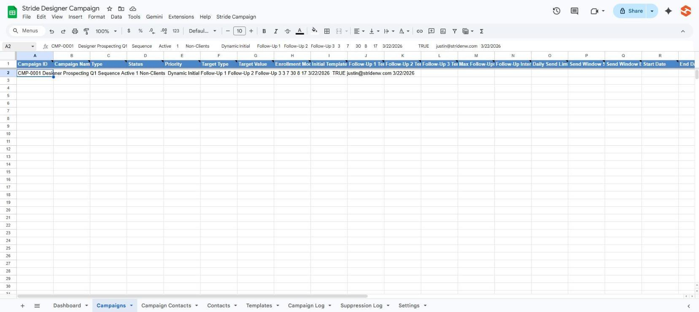
Campaigns tab with a filled-out row ready to activate
Step 5: The system validates your settings. If anything is wrong, it tells you what to fix. If valid, it sets Status = Active and enrolls eligible contacts.
Step 6: Before going live, click Stride Campaign > Preview Campaign Email to send yourself a test.
Step 7: Check your inbox. Verify the email looks correct, links work, and tokens are replaced.
Step 8: When ready to go live, change Test Mode to FALSE in the Campaigns tab. Emails will start sending to real contacts on the next scheduled run (8:30 AM Pacific daily).

5. Running the Designer Prospecting Campaign
This is the original campaign we built the system for. Here is exactly how to set it up:

Template Setup
Step 1: Go to the Templates tab. You should have 4 rows:
Row 2: Template Name = Initial, Subject = your v8 subject line, HTML Body = the v8 email you provided.
Row 3: Template Name = Follow-Up 1, shorter/warmer version.
Row 4: Template Name = Follow-Up 2, even shorter.
Row 5: Template Name = Follow-Up 3, final warm close.

TIP: If the Templates tab is empty, paste your HTML email directly into column D for each row. Make sure {{First Name}}, {{BookingURL}}, {{EMAIL_HASH}}, and {{UNSUB_URL}} tokens are in the HTML.

Campaign Setup
Step 1: Click Stride Campaign > Create New Campaign.
Step 2: Name it: Designer Prospecting Q1 (or whatever you prefer).
Step 3: Fill in the Campaigns row:

Type: Sequence
Priority: 1
Target Type: Non-Clients
Target Value: (leave blank)
Enrollment Mode: Dynamic
Initial Template: Initial
Follow-Up 1 Template: Follow-Up 1
Follow-Up 2 Template: Follow-Up 2
Follow-Up 3 Template: Follow-Up 3
Max Follow-Ups: 3
Follow-Up Interval Days: 7
Daily Send Limit: 30
Send Window Start: 8
Send Window End: 17
Test Mode: TRUE
Test Recipient: justin@stridenw.com

Step 4: Select the row and click Stride Campaign > Activate Campaign.
Step 5: Click Stride Campaign > Preview Campaign Email to test.
Step 6: Check your inbox. Verify everything.
Step 7: Set Test Mode to FALSE when ready to go live.

TIP: The campaign runs automatically at 8:30 AM Pacific every day. You do not need to do anything after activation. You will receive a daily digest email with stats.

6. Managing Active Campaigns

Pausing a Campaign
If you need to temporarily stop a campaign (e.g., holiday, content issue):
Step 1: Go to the Campaigns tab and click on the campaign row.
Step 2: Click Stride Campaign > Pause Campaign.
Status changes to Paused. No emails will be sent. Contacts keep their current progress.
To resume, change Status back to Active manually in the cell. Or create a new version.

Completing a Campaign
When a campaign is done or you want to permanently stop it:
Step 1: Select the campaign row.
Step 2: Click Stride Campaign > Complete Campaign.
Status changes to Complete. All Pending contacts in Campaign Contacts are marked Complete. The campaign will never send again.

WARNING: Completing a campaign is permanent. You cannot reactivate a completed campaign. If you need to run it again, create a new one.

Editing a Campaign
You can edit most fields while a campaign is in Draft or Paused status:
Change the daily send limit, send window, follow-up interval, or templates.
Change targeting (Target Type, Target Value).
Change Test Mode on/off.

WARNING: Do not change the Campaign ID or Campaign Name after activation. Other tabs reference these values.

Viewing Campaign Stats
Stats are automatically updated after each run. You can see them in:
The Campaigns tab: columns Total Sent, Total Replied, Total Bounced, Total Unsubscribed, Total Converted.
The Dashboard tab: click Stride Campaign > Refresh Dashboard for a summary.
Your daily digest email: sent to you after each run with a per-campaign breakdown.

Running Campaigns Manually
Campaigns run automatically at 8:30 AM Pacific. If you want to run them manually:
Click Stride Campaign > Run All Campaigns.
This processes all active campaigns immediately.
TIP: Manual runs respect all the same rules: daily limits, send windows, suppression, etc.

7. Creating Email Templates

Templates are stored in the Templates tab. Each row is one template with 5 columns:
Column A: Template Name (must match exactly what you put in the Campaigns tab).
Column B: Subject Line (can include tokens like {{First Name}}).
Column C: Preview Text (the text that shows in inbox previews before opening).
Column D: HTML Body (the full HTML email code).
Column E: Version (optional, for your tracking, e.g., v1, v2).

Available Tokens
When building HTML templates, use these tokens anywhere in the subject or body. The system replaces them automatically before sending:

Contact Tokens
{{First Name}} — the contact's first name
{{Last Name}} — the contact's last name
{{Full Name}} — first + last combined
{{Company}} — the contact's company name
{{Email}} — the contact's email address

Link Tokens
{{BookingURL}} — your booking page URL (from Settings tab)
{{EMAIL_HASH}} — unique hash per contact for click tracking
{{UNSUB_URL}} — one-click unsubscribe link (REQUIRED in every email)

Sender Tokens
{{Sender Name}}, {{Sender Phone}}, {{Sender Email}}, {{Website URL}} — pulled from Settings

Date Tokens
{{Current Year}}, {{Current Month}}, {{Send Date}} — auto-filled at send time

Custom Tokens
{{Custom 1}}, {{Custom 2}}, {{Custom 3}} — set per campaign in the Campaigns tab. Use for promo codes, event dates, special offers, etc.

WARNING: Every email MUST include {{UNSUB_URL}} somewhere in the body. Without it, recipients cannot unsubscribe and you may violate anti-spam laws.

8. Working with Contacts

Adding New Contacts
Simply add a new row to the Contacts tab. Fill in at minimum: First Name (col D), Last Name (col E), and Email (col F). The script auto-fills Date Added, Status = Pending, and Campaign Stage = New.
If you set Existing Client = TRUE, the contact will be available for client-targeted campaigns but excluded from prospecting campaigns.

Using Campaign Tags
To target specific contacts for a campaign, put a tag in the Campaign Tag column (col J). Then in your Campaign row, set Target Type = Campaign Tag and Target Value = your tag.
Example: Put Software Launch in the Campaign Tag column for 50 contacts. Create a campaign targeting Campaign Tag = Software Launch. Only those 50 contacts get the email.

Suppression and Blocking
Contacts are automatically suppressed (blocked from all future emails) when they:
Reply to any campaign email (v1 behavior)
Bounce (email address is invalid)
Unsubscribe (via link or reply keyword)

To manually suppress a contact: set Suppressed = TRUE and fill in Suppression Reason.
To release a suppressed contact: set Suppressed = FALSE, clear the Suppression Reason, and add a note in Manual Release Note explaining why.

Importing Contacts
Click Stride Campaign > Import Contacts to re-import from the two source spreadsheets (Architects list and Client Email Mailing List). This only adds new contacts that don't already exist. It will not create duplicates.

9. Daily Operations

What Happens Automatically
7:30 AM Pacific: checkInbox() runs. Detects replies, bounces, and unsubscribe requests from the past 2 days.
8:30 AM Pacific: runAllCampaigns() runs. Processes all active campaigns, sends eligible emails, schedules follow-ups, updates stats, and sends you the daily digest.

What You Should Do Daily
Check your daily digest email for any issues (bounces, errors, unusual unsubscribe rates).
Optional: Open the spreadsheet and click Stride Campaign > Refresh Dashboard to see current stats.

What You Should Do Weekly
Review the Campaign Contacts tab for replied contacts — these are warm leads.
Review any Converted contacts and update if needed.
Add new contacts if you have them.

Marking Conversions
When a designer books a consultation or becomes a client, go to the Campaign Contacts tab, find their row, and set Converted = TRUE. Also update the Contacts tab: set Converted = TRUE and optionally change Status to Client.

10. Troubleshooting

Menu Not Appearing
Close and reopen the spreadsheet. If still missing, go to Apps Script editor > Triggers (clock icon) and check that an onOpen trigger exists. If not, add one: Function = onOpen, Event = From spreadsheet > On open.

Emails Not Sending
Check the Campaigns tab: Is the campaign Status = Active? Is Test Mode = FALSE?
Check the Settings tab: Is the send window correct for current time?
Check the Campaign Log tab: Look for recent rows with Send Result = Failed. The Error Message column tells you what went wrong.
Check your Google quota: Go to Apps Script editor > Run > getRemainingQuota (if you add one) or check the daily digest for quota info.

Activation Fails Validation
Check the Validation Notes column in the Campaigns tab. Common issues:
Template not found — the Template Name in your campaign doesn't match any row in the Templates tab. Check spelling and case.
Follow-up count mismatch — you set Max Follow-Ups = 3 but only have 2 follow-up templates.
Missing required fields — Daily Send Limit, Send Window, or Templates are blank.

Error: Cannot call SpreadsheetApp.getUi()
This happens when running functions from the Apps Script editor that try to show a dialog. The function still works — check the Execution Log for results instead of expecting a popup.

Duplicate Contacts
The import function deduplicates by email. If you accidentally add duplicates manually, the system will flag them during campaign runs but will not auto-remove them. Delete the duplicate row manually.

11. Quick Reference Card

Menu Commands
Create New Campaign — adds a Draft campaign row
Activate Campaign — validates and starts a campaign (select the row first)
Pause Campaign — temporarily stops a campaign
Complete Campaign — permanently ends a campaign
Preview Campaign Email — sends a test email to yourself
Run All Campaigns — manually trigger all active campaigns now
Check Inbox — scan for replies, bounces, unsubs
Import Contacts — pull new contacts from source spreadsheets
Refresh Dashboard — update the Dashboard tab stats
Send Daily Digest — manually send the daily report email

Campaign Lifecycle
Draft → Active → Paused (optional) → Complete
Draft: Set up all fields, templates, targeting.
Active: Campaign is live and sending. Test Mode should be FALSE for real sends.
Paused: Temporarily stopped. Can be resumed by setting Status back to Active.
Complete: Permanently done. Cannot be reactivated.

Contact Lifecycle (per campaign)
Pending → Sent → Follow-Up Scheduled → Sent → ... → Exhausted/Replied/Converted

Hard Rules
1. One active sequence per contact at a time.
2. No contact receives more than one email in 24 hours.
3. Suppressed contacts are never emailed (bounced, unsubscribed, replied).
4. Exhausted means done with THIS campaign only, not globally.
5. All emails require {{UNSUB_URL}} in the template.

Key URLs
Google Sheet: https://docs.google.com/spreadsheets/d/1p7dmJlqij2KzwAFiXCUBbUTeF5JVvQF7TQlrofp9tcg/
Apps Script: script.google.com (your project)
Stride Website: stridenw.com
Booking Page: stridenw.com/booking-availability

